ORAL PRESENTATIONS - INSTRUCTIONS FOR AUTHORS

- Your presentation will be at the AULA MAXIMA of the School of Medicine.
- Session, date, time are those included in the e mail
- Duration of the presentation is 10 minutes. Please be very careful with this aspect. The chairmen/women have sharp instructions in this respect.
- Discussion will be at the end of the session together with other presentations of the same session. Maximum time for the discussion period is 10 minutes. Therefore, please be concise in your answers. Discussion person to person is also possible after the session and could be included in the web if the chairmen/women consider it interesting.
- Please, 30 minutes at least before presentation let know to our multimedia staff (Mr. Juan Miguel Nuñez) the material to be used for the presentation (slides, CDs, Laptops etc) at the place destined to this task close to the Aula Maxima. They will be there at your disposal at 8:00-8,30 and 10-10,30 during the morning sessions. During the afternoon sessions they will be at 14:00-14,30 and during coffee break .
- Due to the number of presentations and the tight program we will be very grateful to authors presenting by Powerpoint or similar software for bringing a copy of the presentation file in CD-R (avoid CD-RW), avoiding if possible, the use of his/her Laptot. We also recommend Windows files, instead of Mac files to avoid possible changes during the conversion process.
- Please consult any doubt to our Scientific Secretariat at ieb2003.abstracts@metrored-online.com or ieb2003@ugr.es or fax +34952223116.

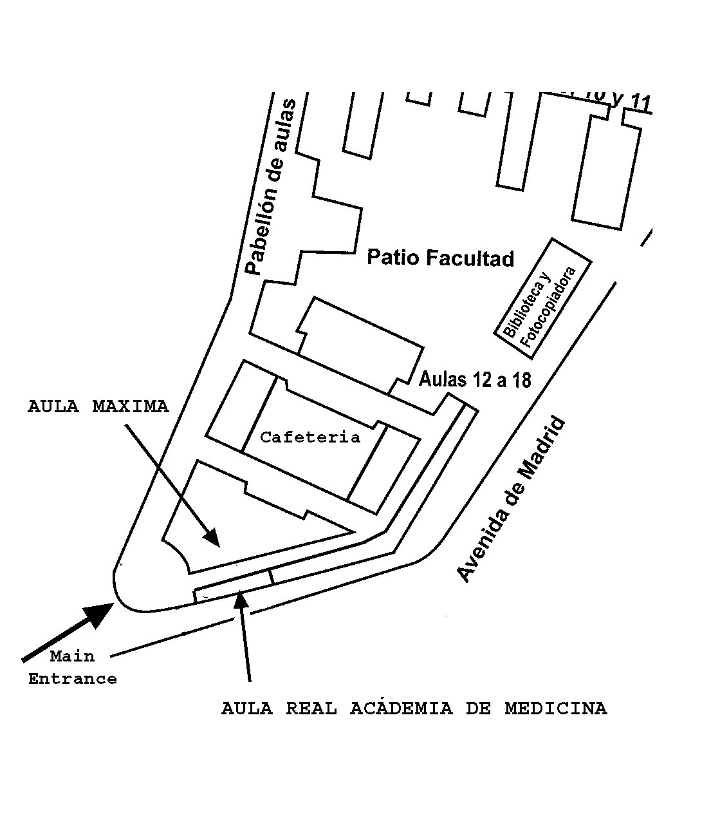

School of Medicine
Ground Floor

