POSTER EXHIBITIONS - INSTRUCTIONS FOR AUTHORS

- The posters should be exhibited in the usual way (printed and fixed to an available stand with fixing materials) during the meeting.

- Dimensions of the available surface at stands are 100x140 cm approximately (some more extra length down is possible)

- The exhibition place will be located in the corridor accessing to the Aula Maxima (see map below)

- Those corresponding to session I-A and IB (posters 1-20) should be exhibited from 9 to 15h during Monday September 8th.

- Those corresponding to sessions IIA and IIB (posters 21-45) should be exhibited from 9 to 15h during Tuesday September 9th.

- In the afternoon one very short presentation can be performed (this is an option) per each poster according to the instructions you have probably received already.

- These mini presentations (similar to those of previous meetings) will be followed at the end of the session by the discussion of the group of posters. In this way the questions of the audience are grouped at the end of the session.

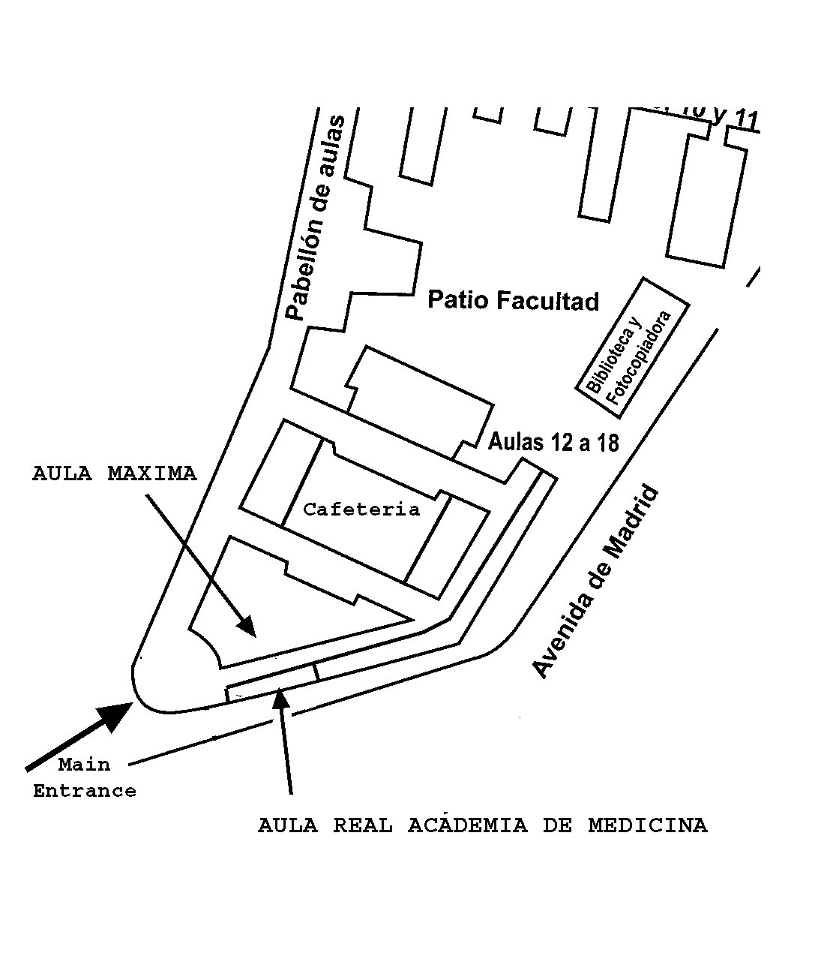

School of Medicine
Ground Floor
Posters AREA

